07/01/2015
Advance Instruction Guide

Office of Travel Services

This is a step-by-step guide to process Advances for employees and students at the University of Connecticut. The guide begins after signing into UConn’s Kuali Financial System (KFS).
- Ensure that all necessary paperwork has been obtained. Below is a list that includes, but is not limited to documentation that may be required depending on the type of advance that’s being requested.
  - Travel Advance: A completed pre-trip Travel WebForm.
  - Education Abroad: Itemized budget, pre-trip Travel WebForm, student roster.
  - Research (Grant and Non-Grant Funded): Signed Promissory Note, an IRB approval letter, and a budget for study.
  - Other Advance: Contact Travel Services.
- On the Main Menu tab: select “Disbursement Voucher” (DV) to initiate a new advance DV.
Under Transactions, Financial Processing, Select Disbursement Voucher

- On the Document Overview: Fill in the following fields according to the type of advance that’s being requested.
  - Description:
    - Travel Advance: Enter “H – Travel Advance” and the Travel Advance ID (located on the TWF). (Example: “H – Travel Advance 16”)
    - Education Abroad: Enter “Ed Abroad Advance - *Program Name/Semester* (Example: “Ed Abroad – Granada Fall 2015”).
    - Research (Grant and Non-Grant Funded): Enter Research Advance and then the study number. (Example: “Research Advance H12-289”).

  - Explanation: Use this box to enter any additional information about the business purpose for the advance.

  - Organization Document Number: Fill in the following fields according to the type of advance that’s being requested.
- Travel Advance: Date of departure for trip in format of MM/DD/YYYY.
- Education Abroad: Expected date that the funds will first be used (MM/DD/YYYY).
- Research: Expected date that the funds will first be used (MM/DD/YYYY).
Below is an example of what a completed Document Overview tab will look like for a Travel Advance:

- On the Payment Information tab:
  - First click on the lookup icon next to Payee ID. On the Payee Lookup screen select Payment Reason Code: “H – Cash, travel Advances, Petty Cash, Study
Abroad”. If you need to search for a Payee you may do so by entering information in the fields provided. If you are searching by Last Name make sure to enter asterisks (*) before and after the name (Ex: *Harzewski*). Once the correct payee appears select Return Value and the address information should populate. Please note that if the address does not populate you will need to enter this information manually.
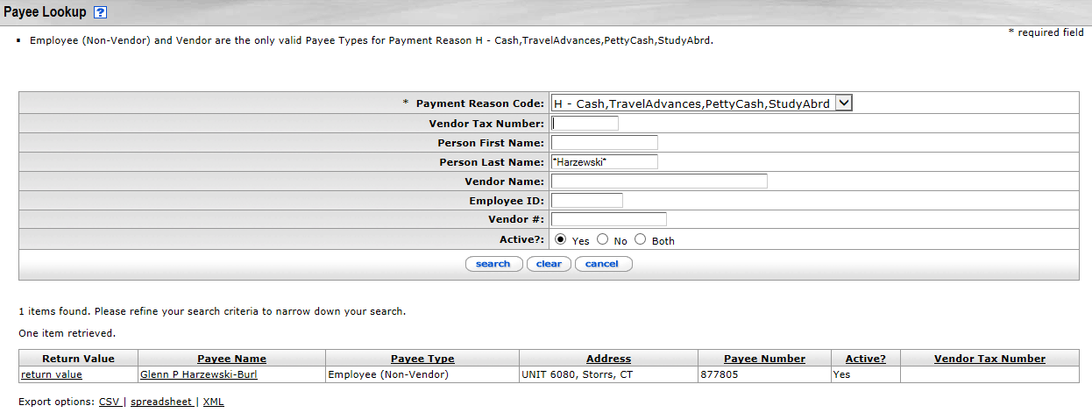

  - Check Amount: This amount must match the advance amount in the accounting line(s) below. Travel Advance Only: Please note advances less than $300.00 will not be processed unless an explanation is attached that explains how the advance is necessary for the completion of the business purpose.

  - Invoice Number: Fill in the following field according to the type of advance that’s being requested.
    - Travel Advance: Travel Advance ID (located on TWF).
    - Education Abroad: Travel Advance ID (located on TWF).
    - Research (Grant and Non-Grant Funded): IRB Protocol Number, Request Number (beginning from 1)

  - Payment Method: This field defaults to “P-Check/ACH” and should not be changed. If the payee is not eligible to receive a check or direct deposit please contact the Travel Office for instructions on how to proceed with issuing the advance.

  - Due Date: The due date should always be within 10 days of the start date of the trip, program, and/or project start date.

  - Invoice Date: Fill in the following field according to the type of advance that’s being requested.

    - Travel Advance: 10 days prior to departure date.
    - Education Abroad: 20 days prior to departure date.
    - Research (Grant and Non-Grant Funded): 10 days prior to when the first subjects will be paid.

- On the Accounting Lines tab fill in the following fields according to the type of advance that’s being requested.
  - Chart Code: UC
  - Account Number: All Travel Advances use 9044680. All other Advances will use an account related to the activity being performed or a department account.
  - Sub-Account:
    - Travel Advance: sub of account of person
    - Research Advance: If you don’t know the traveler’s sub-account use the lookup tool . Once you have clicked on the lookup tool icon verify the chart code and account number fields are filled in with the information provided above. Then search by last name (Ex: *Harzewski*). Click “return value” next to the correct name. Note: if a sub-account cannot be located for the employee, it will have to be set up. Contact Travel Services to have a sub-account created.
    - Education Abroad: sub account of person

  - Object Code:
    - Travel Advance/Student Activities: 1170
    - Education Abroad: 1185
    - Research: 1175

  - Sub-Object and Project Code: These two fields are not required to be filled out, but they can be filled in at the discretion of the department.

  - Org Ref Id: This field must be filled out with an identifier that is unique to each advance issued.
    - Travel Advance: Travel Advance ID (located within TWF)
    - Education Abroad: Travel Advance ID (located within TWF)
    - Research: IRB Protocol Number, Request Number (beginning from 1)

  - Amount: Amount of Travel Advance Request. This amount must match the Check Amount in payment information above.

  - Line Description: Fill in the following field according to the type of advance that’s being requested.
    - Travel/Student Activities/Education Abroad: End date of trip or activity in format MM/DD/YY.
    - Research (Grant and Non-Grant Funded): 90 days from the date of the request. This will be the date that expenses and/or repayment is due.
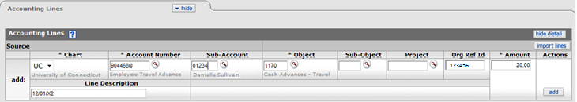
To complete the Accounting Line tab select the “Add” button:

- Special Handling: Special handling is only used for Wire and Prepaid Debit Card advances.
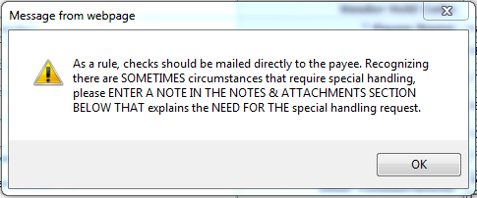
Click OK
- Notes and Attachments: Attach all documentation that is required for the advance to be processed. Paperwork necessary for each advance type is listed above in Step 1.
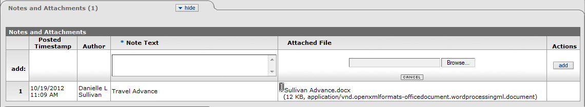

Attached File: To attach the document, click Browse. Locate the saved file and upload. Click “add” and the document will be attached to the DV. Once added, the attachment cannot be changed or removed.
Note Text: Required Field. No specific form must be used. Note that once added, the note text cannot be changed.
Note Text: Required field. No specific form must be used. Note that once added, the note text cannot be changed.

- Ensure all fields are correct on the Disbursement Voucher. If no errors are identified, click “Submit” at the bottom of the DV.

Additional Information
- At any point in time you may go to the Route Log to see where it is in the Workflow and what Future Action Requests are required before payment is made.
- Payees cannot initiate their own Travel Advances.
- Allow for 5 business days for processing. If the advance is needed in less than 5 business days, contact travel@uconn.edu with the DV number(s) to expedite the payment process.
- In order to determine whether the advance has been paid, perform a doc search for the advance using the Document/DV number. Once the Disbursement Voucher has opened, scroll down to the “Pre-Disbursement Processor Status” tab and click Show. Once payment has been processed, you will see a paid date and a payment disbursement number.

