

2017

**Advance Guide**

**A Procedural Guide for Kuali Financial Systems eDocs**

**Office of Travel Services**

**Table of Contents**

|  |  |
| --- | --- |
| **eDoc / Process** | **Page** |
| Initial Advance (DV) | 3 |
| Replenishment (DV)  (For Research Cash Advance Only) | 9 |
| Final Reconciliation of Advance  DV: Reimbursement Owed to Payee  DI: Payee Owes the University | 14  19 |
| Cash Receipt/Advance Deposit (CR/AD) | 25 |

**Initial Advance (DV)**

An advance is money loaned by the University so that the payee does not need to use their own personal funds up front. An advance can be requested for travel expenses that can’t be direct billed and to pay subject incentives for research studies.

This is a step-by-step guide to process advances for the University of Connecticut. The guide begins after signing into UConn’s Kuali Financial System (KFS). All advances are to be repaid or have valid receipts submitted to a KFS account within the following timeframes:

* Travel Advance: 15 days after the return date of the trip
* Education Abroad: Every 30 days from the start of the session and a final close out within 30 days of the end of the session.
* Research (Grant and Non-Grant Funded): Every 30 days from the start of the study and a final close out within 30 days of the end of the study. When an advance has not been replenished or used for research for 30 days the funds may be required to be repaid to the University. For confidential IRB approved subject incentive payments the department and responsible Principal Investigator are required to keep personal identifying information connecting the receipt log submitted in KFS with the individual receiving the payment. Including name, date, amount received, and signature or initials acknowledging receipt of the payment.

1. Ensure that all necessary paperwork has been obtained. Below is a list that includes, but is not limited to, documentation that may be required to be attached on the eDoc depending on the type of advance that is being requested.
   * Travel Advance: Travel WebForm showing signed Promissory Note
   * Education Abroad: Itemized budget, signed Promissory Note, student roster, and a Travel WebForm if advance is just for employee travel expenses
   * Research (Grant and Non-Grant Funded): Signed Promissory Note, an IRB approval letter, and a budget for study.
   * Other Advance: Contact Travel Services.
2. 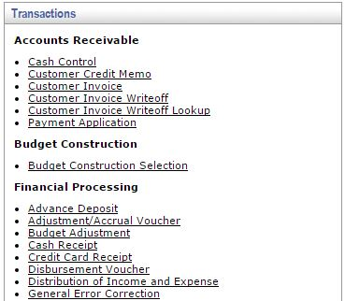On the **Main Menu** tab: select “Disbursement Voucher” (DV) to initiate a new advance.

**Under Transactions, Financial Processing, Select Disbursement Voucher**

1. On the **Document Overview**: Fill in the following fields according to the type of advance that is being requested.
   * **Description**:
     + Travel Advance: Enter “H – Travel Advance” - Travel Advance ID (located on the Travel WebForm). (Example: “1175”)
     + Education Abroad: Enter “Ed Abroad Advance” - Program Name and Semester. (Example: “Ed Abroad – Granada Fall 2015”).
     + Research (Grant and Non-Grant Funded): Enter “Research Advance – KFS Account Number-Last Name of Payee”
   * **Explanation**: Use this box to enter any additional information about the business purpose for the advance. This is an optional field.
   * **Organization Document Number**: Fill in the following fields according to the type of advance being requested.

* Travel Advance: Date of departure for trip (MM/DD/YYYY).
* Education Abroad & Research: Expected date that the funds will first be used (MM/DD/YYYY).

Below is an example of what a completed **Document Overview** tab will look like for a Travel Advance:



1. On the **Payment Information** tab:
   * First click on the lookup icon next to **Payee ID** 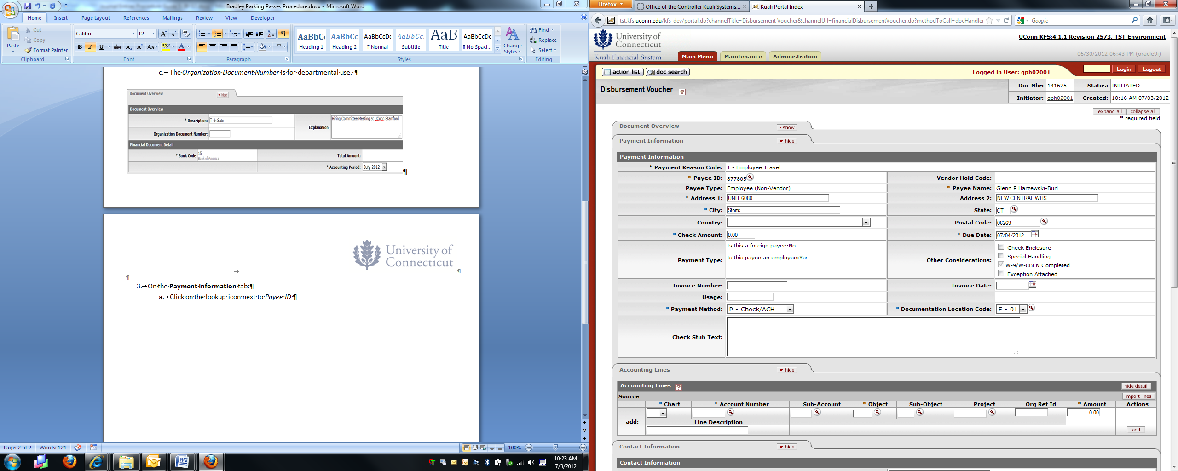. On the **Payee Lookup** screen select Payment Reason Code: “H – Cash, Travel Advances, Petty Cash, Ed

Abroad”. Search for the payee using the first/last name or employee ID fields. If you are searching by name make sure to enter asterisks (*) before and after the name (Ex: *Harzewski*). Select **Return Value** next to the correct payee and the payee’s personal information should populate into the DV. Please note that if the address does not populate you will need to enter this information manually.

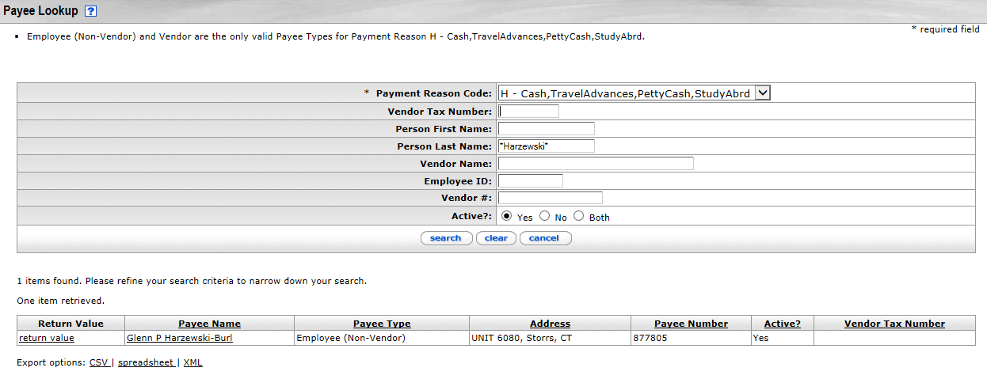

* + **Check Amount**: This amount must match the advance amount in the accounting line(s) below.
    - Travel Advance: Travel advances less than $300.00 will not be processed unless an explanation is attached that explains how the advance is necessary for the completion of the business purpose.
    - Research (Grant and Non-Grant Funded): Special care should be taken to determine the amount of the advance requested. The advance amount should not exceed an amount where replenishment may be accomplished (typically as frequently as 2 weeks for active projects; ***no less frequent than 3 months***).
  + **Invoice Number**: Will differ depending on the type of advance being requested.
    - Travel Advance: Travel Advance ID (located on Travel Webform).
    - Education Abroad: Travel Advance ID (located on Travel Webform).
    - Research:
      1. Grant Sponsored Acct. Account Number Designated by Sponsored Program Services - (beginning from 1).
      2. Non-Sponsored Acct. IRB Approval Number– (beginning from 1).
  + **Payment Method**: Only select the Payment Methods listed below.
    - P – Check/ACH: Direct Deposit for Employees & paper check for non-employees.
    - D – Prepaid: For employees that have UConn’s Prepaid Debit card requested through [Bursar’s Office](http://bursar.uconn.edu/cash-operations/). ***Note: Special Handling must also be checked for Prepaid Card load.***
  + **Due Date**: The due date is the date that the funds will be disbursed. This will be no longer than 10 days before the start date of the trip, program, and/or date the funds will be used.
  + **Special Handling**: This is only used for Prepaid card processing. Additional information must be entered in the Special Handling tab when this option is checked.
  + **Invoice Date**: Use the current day’s date.

1. On the **Accounting Lines** tab fill in the following fields according to the type of advance that’s being requested.
   * **Chart Code**: UC
   * **Account Number**:
     + Travel Advance: 9044680.
     + Education Abroad: Account should correspond to the program/location
     + Research:
       1. Grant Sponsored Acct. The account used for the advance should be a designated 4 Ledger Subject Incentive Account. If a designated 4 Ledger account has not been established for the subject incentive activity, the requestor should contact the Sponsored Program Services Post-Award team to setup the account.
       2. Non-Sponsored Acct. Account should correspond to study
   * **Sub-Account**:
     + Travel Advance: Use the sub-account assigned to the payee. If there is no sub-account, please contact Travel.
     + Education Abroad: Time period travel is occurring (Fall, Spring, Summer etc.)
     + Research:
       1. Grant Sponsored Acct. Correspond with study
       2. Non-Sponsored Acct. Correspond with study
   * **Object Code**:
     + Travel Advance: 1170
     + Athletics: 1195
     + Education Abroad: 1185
     + Research: 1175
   * **Sub-Object**: Do not use this field
   * **Project Code:** This optional field can be completed at the discretion of the department.
   * **Org Ref Id**:
     + Travel Advance: Use the 4 digit Travel WebForm ID.
     + Education Abroad: Please leave blank
     + Research: Please leave blank
   * **Amount**: Amount of Advance Requested. This amount must match the check amount in payment information above.
   * **Line Description**: Fill in the following field according to the type of advance being requested.
     + Travel/Education Abroad: End date of trip or activity in format MM/DD/YY. Ed Abroad programs require a DI every 30 days to expense used funds.
     + Research (Grant and Non-Grant Funded): Enter the date when funds are expected to be fully disbursed. Research studies require a DV (replenishments) or DI every 30 days to expense used funds

To complete the **Accounting Line** tab select the “*Add*” button:

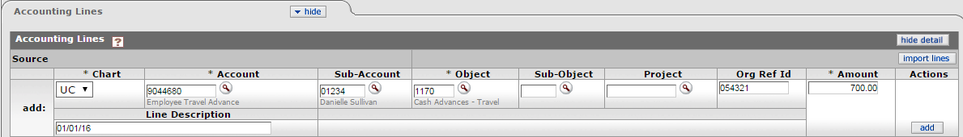

1. **Notes and Attachments**: Attach all documentation that is required for the advance to be processed. Paperwork necessary for each advance type is listed above in Step 1.
2. To attach a document first add a short description in the Note Text box.
3. Next click on the ***browse*** button which will then allow you to select a saved file from a location on your computer. Once you select the file, be sure to click the “Add” button in order to save your attachment

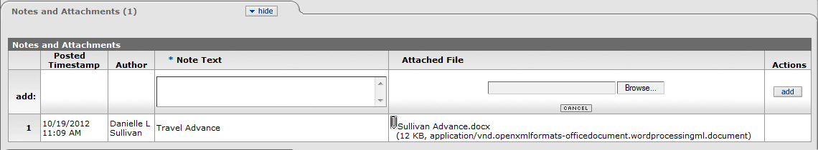

1. Ensure all fields are correct. If no errors are identified, click “Submit” at the bottom of the DV.

**Additional Information**

* At any point in time you may go to the **Route Log** to see where it is in the Workflow and what future action requests are required before payment is made.
* Payees cannot initiate their own Travel Advances.
* Allow 5 business days for processing. If the advance is needed in less than 5 business days, contact [travel@uconn.edu](mailto:travel@uconn.edu) with the DV number(s) to expedite the payment process.
* In order to determine whether the advance has been paid, perform a doc search for the advance using the Document/DV number. Once the Disbursement Voucher has opened, scroll down to the “**Pre-Disbursement Processor Status**” tab and click **Show**. Disbursement detail will be visible in this tab.

**Advance Reconciliation**

The advance reconciliation process is done after a payee receives an advance for either travel or as part of a research study. Below is the breakdown regarding the repayment timeframe and what type of transaction should be entered in the Kuali Financial System (KFS).

This is a step-by-step guide to reconcile advances for the University of Connecticut. The guide begins after signing into UConn’s Kuali Financial System (KFS).

All advances are to be repaid or have valid receipts submitted to a KFS account within the following timeframes:

* Travel Advance: 15 days after the return date of the trip
* Education Abroad: Every 30 days from the start of the session and a final close out within 30 days of the end of the session.
* Research (Grant and Non-Grant Funded): Every 30 days from the start of the study and a final close out within 30 days of the end of the study. When an advance has not been replenished or used for research for 30 days the funds may be required to be repaid to the University. For confidential IRB approved subject incentive payments the department and responsible Principal Investigator are required to keep personal identifying information connecting the receipt log submitted in KFS with the individual receiving the payment. Including name, date, amount received, and signature or initials acknowledging receipt of the payment.

**Replenishment (DV) (For Research Cash Advance Only)**

A replenishment is submitted when the original advance that was issued has been used up and additional funds are still required. An example of when a replenishment can be requested is for a research study with subject incentives.

**For Replenishments:** There will be a total of at least three accounting lines. The net of these accounting lines will equal the check amount.

1. Ensure that all necessary paperwork has been obtained. Below is a list that includes, but is not limited to documentation that may be required depending on the type of advance that is being requested.
   * Research (Grant and Non-Grant Funded): An IRB approval letter, promissory note, receipts and/or expense summary. **Please ensure that no identifying information is included regarding subject incentives. All identifying information must be retained by the PI & Fiscal Officer and easily accessible if requested in an audit.**
   * Other Advance: Contact Travel Services.
2. On the **Main Menu** tab: select “Disbursement Voucher” (DV) to initiate a replenishment DV.



**Under Transactions, Financial Processing, Select Disbursement Voucher**

1. On the **Document Overview**: Fill in the following fields.

* **Description**: Research (Grant and Non-Grant Funded): Enter “Research Advance – KFS Account Number-Last Name of Payee”
  + **Explanation**: Use this box to enter any additional information about the business purpose for the advance. This is an optional field.
  + **Organization Document Number**: This is an optional field

1. On the **Payment Information** tab:
   * First click on the lookup icon next to **Payee ID****. On the **Payee Lookup** screen select Payment Reason Code: “H – Cash, Travel Advances, Petty Cash, Ed

Abroad”. Search for the payee using the first/last name or employee ID fields. If you are searching by name make sure to enter asterisks (*) before and after the name (Ex: *Harzewski*). Select **Return Value** next to the correct payee and the payee’s personal information should populate into the DV. Please note that if the address does not populate you will need to enter this information manually.



* + **Check Amount**: This amount must match the advance amount in the accounting line(s) below.
    - Research (Grant and Non-Grant Funded): Special care should be taken to determine the amount of the advance requested. The advance amount should not exceed an amount where replenishment may be accomplished (typically as frequently as 2 weeks for active projects; ***no less frequent than 3 months***).
  + **Invoice Number**: Will differ depending on if the research is Grant Sponsored or not.
    - Research :
      1. Grant Sponsored Acct. Account Number Designated by Sponsored Program Services - (beginning from 1).
      2. Non-Sponsored Acct. IRB Approval Number– (beginning from 1).
  + **Payment Method**: Only select the Payment Methods listed below.
    - P – Check/ACH: Direct Deposit for Employees & paper check for non-employees.
    - D – Prepaid: For employees that have UConn’s Prepaid Debit card requested through [Bursar’s Office](http://bursar.uconn.edu/cash-operations/). ***Note: Special Handling must also be checked for Prepaid Card load.***
  + **Special Handling**: This is only used for Prepaid card processing. Additional information must be entered in the Special Handling tab when this option is checked.
  + **Invoice Date**: Use the current day’s date.

1. On the **Accounting Lines** tab fill in the following fields.

* **Chart Code:** UC
* **Account Number**: Use the same account number that was used for the original disbursement (For Grant activity, this account should be a designated 4 Ledger Subject Incentive Account).
* **Sub-Account**: Use the same sub-account as the original disbursement.
* **Object Code**:
  + - Research: 1175
* **Sub-Object:** Do not use this field.
* **Project Code:** This optional field can be completed at the discretion of the department.
* **Org Ref Id**: This should mirror the accounting line of the original disbursement.
* **Amount**: Amount of requested disbursement. This amount should match the check amount in payment information section of the DV.
* **Re-enter** an additional accounting line that mirrors the above line, however enter the amount as negative. Please note that the amount in this accounting line should match the total receipts/supporting documents. In some cases, this will not be the same as the check amount.
  1. Enter **additional accounting line(s)** to reflect the expense amount as a positive number. The account number will be the account that is funding the expenses. The object code should be 7045 (Subject Incentives). The total amount should equal the accounting line that was entered as a negative number. Click “Add” on each accounting line.

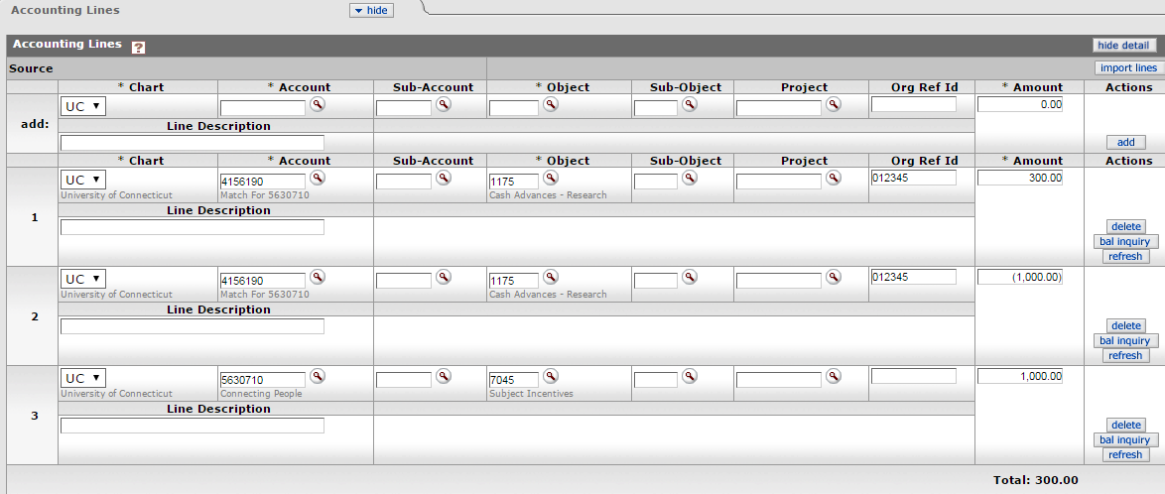An example of replenishment accounting lines are below. In this example, the payee incurred expenses of $1,000 for subject incentives, but is only requesting a replenishment check for $300. The total check amount will mirror that of the first accounting line.

1. **Notes and Attachments**: Attach all documentation that is required for the advance to be processed. Please refer to step 1 regarding proper documentation needed. **(Please ensure that no identifying information is included regarding subject incentives.) All identifying information must be retained by the PI & Fiscal Officer and easily accessible if requested in an audit.**
2. To attach a document first add a short description in the Note Text box.
3. Next click on the ***browse*** button which will then allow you to select a saved file from a location on your computer. Once you select the file, be sure to click the “Add” button in order to save your attachment



1. Ensure all fields are correct on the Disbursement Voucher. If no errors are identified, click “Submit” at the bottom of the DV.

**Additional Information**

* At any point in time you may go to the **Route Log** to see where it is in the Workflow and what future action requests are required before payment is made.
* Payees cannot initiate their own advances.
* Allow 5 business days for processing. If the advance is needed in less than 5 business days, contact [travel@uconn.edu](mailto:travel@uconn.edu) with the DV number(s) to expedite the payment process.
* In order to determine whether the advance has been paid, perform a doc search for the advance using the Document/DV number. Once the Disbursement Voucher has opened, scroll down to the “**Pre-Disbursement Processor Status**” tab and click **Show**. Disbursement detail will be visible in this tab.

**Advance Reconciliation (DV) Reimbursement Owed to Payee**

A final reimbursement only occurs when the person who received the advance has used all advanced funds and had to spend personal funds for qualified expenses and the person is due a reimbursement.

1. Ensure that all necessary paperwork has been obtained. Below is a list that includes, but is not limited to documentation that may be required depending on the type of advance that was requested.
   * Travel Advance: An approved version of the post-trip Travel WebForm and all supporting reimbursement documentation
   * Education Abroad: Student Roster, spreadsheet showing all expenses with currency conversions, and all supporting reimbursement documentation. Travel WebForm is only required if expenses are only claimed for individual employee travel.
   * Research (Grant and Non-Grant Funded): Receipts and/or expense summary. **Please ensure that no identifying information is included regarding subject incentives. All identifying information must be retained by the PI & Fiscal Officer and easily accessible if requested in an audit.**
   * Other Advance: Contact Travel Services.
2. On the **Main Menu** tab: select “Disbursement Voucher” (DV) to initiate a replenishment DV.



**Under Transactions, Financial Processing, Select Disbursement Voucher**

1. On the **Document Overview**: Fill in the following fields according to the type of advance being requested.
   * **Description**:
     + Travel Advance: Enter “T – Advance Rec” and the Travel Advance ID (located on the Travel Webform). (Example: “T – Advance Rec 3214”)
     + Education Abroad: Enter “Ed Abroad” - Program Name and Semester. (Example: “Ed Abroad – Granada Fall 2015”).
     + Research (Grant and Non-Grant Funded): Enter “Research Advance – KFS Account Number-Last Name of Payee”
   * **Explanation**: Use this box to enter any additional information about the business purpose for the reimbursement. This is an optional field.
   * **Organization Document Number**: This is an optional field.

Below is an example of what a completed **Document Overview** tab will look like for an Ed Abroad Advance:

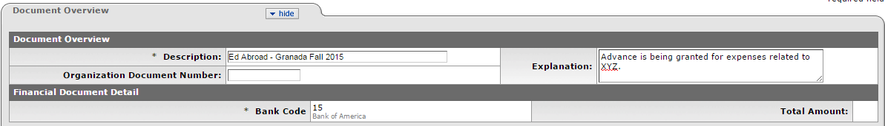

1. On the **Payment Information** tab:
   * First click on the lookup icon next to **Payee ID** **.
   * Travel Advances: On the Payee Lookup screen select Payment Reason Code: “T – Travel Reimbursement”.
   * Education Abroad: On the Payee Lookup screen select Payment Reason Code: “H – Cash, Travel Advances, Petty Cash, Ed Abroad”
   * Research (Grant and Non-Grant Funded): On the Payee Lookup screen select Payment Reason Code: “H – Cash, Travel Advances, Petty Cash, Ed Abroad”.

Search for the payee using the first/last name or employee ID fields. If you are searching by name, make sure to enter asterisks (*) before and after the name (Ex: *Harzewski*). Once the correct payee appears select **Return Value** and the address information should populate. Please note that if the address does not populate you will need to enter this information manually.



* + **Check Amount**: This amount must match the sum of the amount(s) in the accounting line(s) below.
  + **Invoice Number**: Fill in the following field according to the type of advance that is being requested.
    - Travel Advance: Travel Webform ID (located on Travel Webform).
    - Education Abroad: Travel Webform ID (located on Travel Webform).
    - Research:
      1. Grant Sponsored Acct. Account Number Designated by Sponsored Program Services - (beginning from 1).
      2. Non-Sponsored Acct. IRB Approval Number– (beginning from 1).
  + **Invoice Date**: Use the current day’s date.

1. On the **Accounting Lines** tab:

You will enter at least two accounting lines. The net of the two accounting lines will equal the check amount. The first accounting line should be completed as follows:

* + **Chart Code**: UC
  + **Account Number**: Use the same account number that was used for the original disbursement
  + **Sub-Account**: Use the same sub-account as the original disbursement. All travel advances will have a sub-account.
  + **Object Code**:
    - Travel Advance: 1170
    - Athletics: 1195
    - Education Abroad: 1185
    - Research: 1175
  + **Sub-Object:** Do not use this field.
  + **Project Code:** This optional field can be completed at the discretion of the department.
  + **Org Ref Id**: This should mirror the accounting line of the original disbursement.
  + **Amount**: Enter the total amount of the advance as a negative number. Click “Add”.
  + Enter an **additional accounting line** to reflect the expense amount. The account number will be the account that is funding the expenses and the object code should start with a 6 or 7. The total amount should equal the total of the receipts/supporting detail. This accounting line will be a positive number. Click “Add”.
  + The **Total** in bold under the accounting lines should equal the check amount.

**Example of Reimbursement Accounting Lines:**

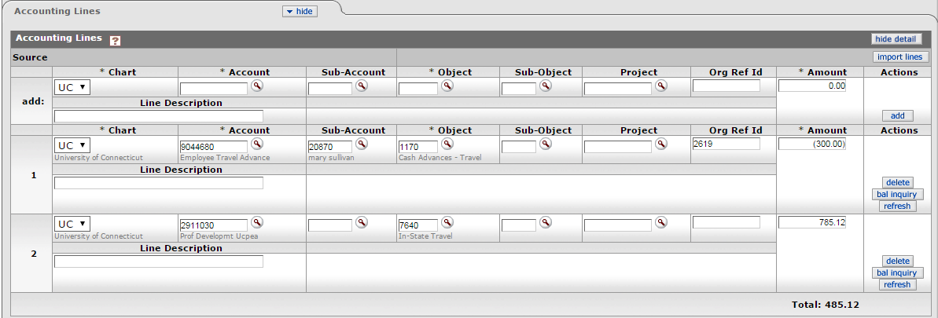

1. You will then need to fill out the **Notes and Attachments** tab. Here you will need to attach all proper documentation for this DV. Please refer to step 1 regarding proper documentation needed.
2. To attach a document first add a short description in the Note Text box.
3. Next click on the ***browse*** button which will then allow you to select a saved file from a location on your computer. Once you select the file, be sure to click the “Add” button in order to save your attachment.

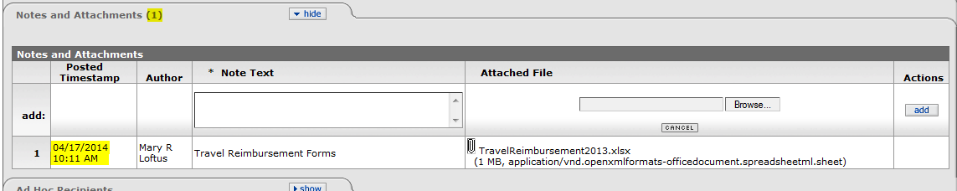

**Additional Information**

* At any point in time you may go to the **Route Log** to see where it is in the Workflow and what ***Future Action Requests*** are required before payment is made.
* Payees cannot initiate their own disbursements
* In order to determine whether the advance has been paid, perform a doc search for the advance using the Document/DV number. Once the Disbursement Voucher has opened, scroll down to the “**Pre-Disbursement Processor Status**” tab and click **Show**. Disbursement detail will be visible in this tab.

**Distribution of Income and Expense (DI) Payee Owes the University**

When an employee is ready to close an outstanding advance and does not require an additional reimbursement, a Distribution of Income and Expense (DI) document needs to be submitted in Kuali Financial System (KFS) to expense funds on the advance that was issued.

All advances are to be repaid or have valid receipts submitted to a KFS account within the following timeframes:

* Travel Advance: 15 days after the return date of the trip
* Education Abroad: Every 30 days from the start of the session and a final close out within 30 days of the end of the session.
* Research (Grant and Non-Grant Funded): Every 30 days from the start of the study and a final close out within 30 days of the end of the study. When an advance has not been replenished or used for research for 30 days the funds may be required to be repaid to the University. For confidential IRB approved subject incentive payments the department and responsible Principal Investigator are required to keep personal identifying information connecting the receipt log submitted in KFS with the individual receiving the payment. Including name, date, amount received, and signature or initials acknowledging receipt of the payment.

Ensure that all necessary paperwork has been obtained. Below is a list that includes, but is not limited to documentation that may be required depending on the type of advance that was requested.

* + Travel Advance: An approved version of the post-trip Travel WebForm and all supporting reimbursement documentation
  + Education Abroad: Student Roster, spreadsheet showing all expenses with currency conversions, and all supporting reimbursement documentation. Travel WebForm is only required if expenses are only claimed for individual employee travel.
  + Research (Grant and Non-Grant Funded): Receipts and/or expense summary. **Please ensure that no identifying information is included regarding subject incentives. All identifying information must be retained by the PI & Fiscal Officer and easily accessible if requested in an audit.**
  + Other Advance: Contact Travel Services.

If an additional reimbursement is required, please see Replenishment/Reimbursement Guide

1. After logging into Kuali, on the **Main Menu** tab in KFS, open a DI by clicking on the link labeled Distribution of Income and Expense. This link can be found on the far left of the page under the section labeled “Transactions” and under the subsection labeled “Financial Processing”.

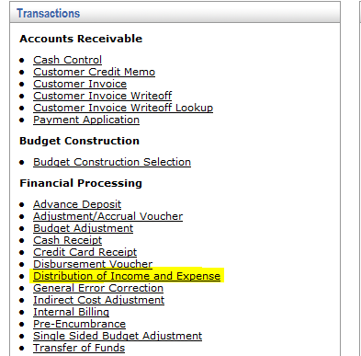

1. On the *Document Overview*: Fill in the following fields.

* **Description**:
  + Travel Advance: Enter “Advance Recon.” – Last Name of Payee
  + Education Abroad: Enter “Ed Abroad” - Program Name and Semester. (Example: “Ed Abroad – Granada Fall 2015”)
  + Research (Grant and Non-Grant Funded): Enter “Research Advance – KFS Account Number-Last Name of Payee”
* **Explanation**: Use this box to enter any additional information about the business purpose for the reconciliation. This is an optional field.
* **Organization Document Number**: This is an optional field.

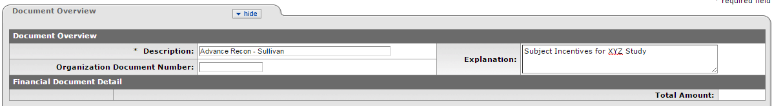

1. The next tab that needs to be filled out is the **Accounting Lines** tab. *This tab needs to be filled out carefully to make sure the advance is reconciled correctly*.
2. The “**From”** accounting line should closely mirror the accounting line from the original advance disbursement except for the amount field.
   * **Chart Code**: UC
   * **Account Number**:
     + Travel Advance: 9044680
     + Education Abroad: Use the same account number that was used for the original disbursement.
     + Research:
       1. Grant Sponsored Acct. Use the same account number that was used for the original disbursement. This account should be a designated 4 Ledger Subject Incentive Account.
       2. Non-Sponsored Acct. Use the same account number that was used for the original disbursement.
   * **Sub-Account**:
     + Travel Advance: Use the same sub-account as the original disbursement. This is the sub-account assigned to the payee.
     + Education Abroad: Use the same sub-account as the original disbursement. Time period travel occurred (Fall, Spring, Summer etc.)
     + Research:
       1. Grant Sponsored Acct. Use the same sub-account as the original disbursement. This should correspond with the study.
       2. Non-Sponsored Acct. Use the same sub-account as the original disbursement. This should correspond with the study.
   * **Object**:
     + Travel Advance: 1170
     + Athletics: 1195
     + Education Abroad: 1185
     + Research: 1175
     + Other: 1190
   * **Sub-Object**: Do not use this field
   * **Project Code**: This optional field can be completed at the discretion of the department.
   * **Org Ref ID**: For Travel Advances, use the 4 digit Travel WebForm ID. This should mirror the accounting line of the original disbursement.
   * **Amount**: Should be the amount the employee is *claiming* with supporting documentation, this will be either equal to or less than the outstanding advance amount. When the line is complete click the “Add” button next to the amount box
   * **Line Description**:This field is optional

Your accounting line should look similar to the example shown below:

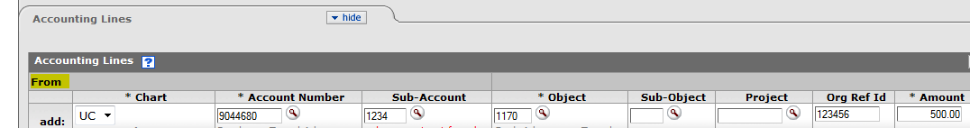

b. The next accounting line you will need to fill out is the **To** accounting line.

* **Chart Code**: UC.
* **Account Number**: Enter the account you would like to charge the expenditure to. You can add multiple accounting lines in this section if you need to.
* **Sub-Account**: This field is optional.
* **Object Code**: Enter the object code for the expense.
  + Travel Advance: 7640, 7635, 7630 etc.
  + Education Abroad
  + Research: 7045
* **Sub-Object**: Do not use this field
* **Project Code**: This optional field can be completed at the discretion of the department.
* **Org Ref ID**: This field doesn’t need to be completed on the To side.
* **Amount**: Should be the amount the employee is *claiming*.
* **Line Description**: This field is optional.

*The amount(s) entered in the accounting line(s) under the* ***To*** *tab must equal the amount entered in the* ***From*** *tab.* Once this Amount box is filled out click the “Add” button next to the amount box. Your accounting line should look similar to the example shown below:



1. You will then need to fill out the **Notes and Attachments** tab. Here you will need to attach all proper documentation for this DI. Please refer to step 1 regarding proper documentation needed.
2. To attach a document first add a short description in the Note Text box.
3. Next click on the ***browse*** button which will then allow you to select a saved file from a location on your computer. Once you select the file, be sure to click the “Add” button in order to save your attachment.



1. The last tab you will need to fill out is the **Ad Hoc Recipient** tab for specific DI’s reconciling an advance.

* Travel Advance: Do not ad-hoc. This DI will route to Travel Services automatically
* Education Abroad: Ad-hoc **Travel Services** APPROVE
* Research:
  1. Grant Sponsored Acct. Do not ad-hoc. This will route to Sponsored Programs for review
  2. Non-Sponsored Acct. Ad-hoc **Travel Services** APPROVE

Click on the show tab of Ad Hoc Recipient, then make sure under Ad Hoc Group Requests the action requested is set to APPROVE. Then click on the magnify glass and under group names search *Travel Services* (be sure to use the * when performing your search). Then click on return value and click add under action.



1. After all the tabs have been filled out correctly and the appropriate attachments are on the DI, click “submit”.

**Please note**: The advance amount disbursed minus the receipted amount on the DI will equal the amount of money the employee owes back to the University. Please see below regarding instructions on depositing excess/unused funds.

**Cash Receipt/Advance Deposit (CR/AD)**

All advances are to be repaid or have valid receipts submitted to a KFS account within the following timeframes:

* Travel Advance: 15 days after the return date of the trip
* Education Abroad: Every 30 days from the start of the session and a final close out within 30 days of the end of the session.
* Research (Grant and Non-Grant Funded): Every 30 days from the start of the study and a final close out within 30 days of the end of the study. When an advance has not been replenished or used for research for 30 days the funds may be required to be repaid to the University. For confidential IRB approved subject incentive payments the department and responsible Principal Investigator are required to keep personal identifying information connecting the receipt log submitted in KFS with the individual receiving the payment. Including name, date, amount received, and signature or initials acknowledging receipt of the payment.

**Depositing Excess/Unused Funds**

Please follow the [instructions](http://bursar.uconn.edu/cash-operations/cash-operations-depositing-departmental-receipts/) found on the Bursar’s Office website when depositing excess/unused funds.

Repayment of unused funds may also be returned by mailing a check to Travel Services with the DV number of the original advance and the Travel WebForm ID (travel advances only).