2015
KFS Distribution of Income and Expense Guide for Travel Advances
For UConn Employees and Students
Office of Travel Services

How to Create Distribution of Income and Expense Documents
When a traveler receives an advance for a trip but does not use up the entire advance, a Distribution of Income and Expense (DI) document needs to be submitted in Kuali Financial System (KFS) to reconcile the advance that was issued. Here is a step by step guide on how to submit a DI; the instructions begin after you login to KFS.
1. On the Main Menu tab in KFS you first need to open a DI by clicking on the link labeled Distribution of Income and Expense. This link can be found on the far left of the page under the section labeled “Transactions” and under the subsection labeled “Financial Processing”.
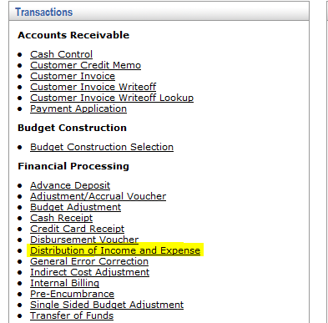
For example, an employee received a $700.00 travel advance but only spent $650.00 of the advance. A DI would need to be done to apply the $650.00 to the correct expenditures in KFS. Then, the employee would write a personal check back to the UConn for the $50.00 they didn’t spend.
Once you click on this link a new DI document will open and you can begin filling out the necessary information.
2. Next you can begin by filling out the Document Overview tab. Fill in the following fields according to the type of advance that was issued:
- In the Description:
- Travel Advance: “Travel Advance Reconciliation” and then the traveler’s last name. Due to the space limitation you only can enter up to eight characters for the traveler’s last name.
- Education Abroad: Program name and Semester. Ex: Paris – Fall 2015.
- Research: the Traveler’s name and Study Number
- Next, in the Explanation box you should write any additional information. Once this box in the Document Overview tab is complete, it should look like the example below:
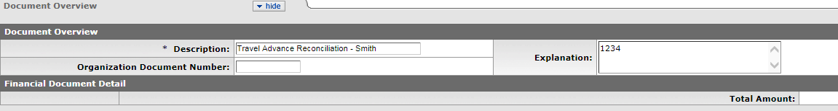

3. The next tab that needs to be filled out is the Accounting Lines tab. This tab needs to be filled out carefully to make sure the advance is reconciled correctly.
In the From accounting line:
- In the Chart box select “UC” from the drop down box
- In the Account Number box”
  - Travel Advance: “9044680” which is the Employee Travel Advance account.
  - Education Abroad/Research: Enter the same account number that was used to issue the original advance.
- In the Sub Account box please enter the traveler’s sub account. If you are unsure of their sub account number you can look it up by clicking on the magnifying glass icon next to the sub account box. When you click this it will bring you to a search page. The information that should be filled out to complete a search is as follows:
1. Enter “UC” in the Chart Code Box.
2. Enter “9044680” in the Account Number Box.
3. Enter the traveler’s last name in the format asterisk, their last name, asterisk (*Last name*). After this information is filled out you should hit the search button and then names that meet your search criteria should appear. Below is an example of how the page will look before you hit the search button:
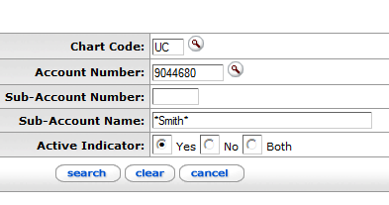
Next to the traveler’s name you would like to choose click the Return Value link. This will then bring you back to the page of your DI and the traveler’s sub account will now be populated in the Sub Account box.

- The Object Code box:
  - Travel Advances: should always be 1170
  - Education Abroad: 1185
  - Research: 1175
- The Org Ref Id box:
  - Travel Advances: Travel Advance ID (located within the Travel WebForm)
  - Research: IRB protocol number, request number (beginning from 1)
- The Amount box should be the amount the traveler is claiming. The advance amount issued minus this amount should equal the amount of money the individual owes back to the University. When the line is complete hit the “Add” button next to the From accounting line. The finished accounting line should look exactly like the accounting line on the original advance DV that was issued except for the amounts may differ. Here is an example below of what this accounting line should look like.
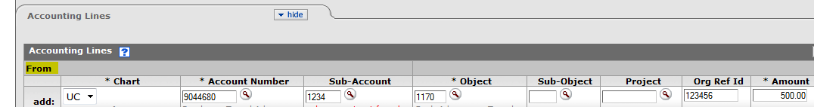

4. The next accounting line you will need to fill out is the To accounting line.
- In the Chart box select “UC” from the drop down list.
- In the Account Number box you should enter the account you would like the charge the expenditure to. You can add multiple accounting lines in this section if you need to.
- In the Object code box enter the appropriate expense object code. Use the lookup tool if you are unsure of what object code number to use.
- Last the Amount box should be the amount the traveler is claiming. The advance amount issued minus this amount will equal the amount of money the traveler owes back to the University. The amount(s) entered in the accounting line(s) under the To tab must equal the amount entered in the From tab. Once this Amount box is filled out click the “Add” button next to the To accounting line. Your accounting line should look something like the example shown below:

5. The last tab you will need to fill out is the Notes and Attachments tab. Here you will need to attach all proper documentation for this DI. To attach a document first add a short description in the Note Text box. Next click on the browse button which will then allow you to select a saved file from a location on your computer. Once you select the file you can click the “Add” button next to the attachment. After you have attached an item the page should look like this:
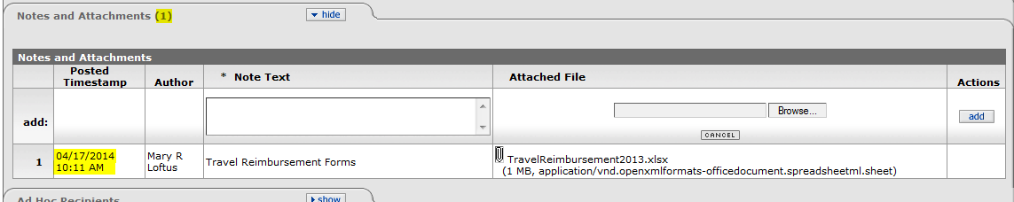

There will be a timestamp next to your attachment and the tab will show how many attachments you have added in parentheses as well. After all the tabs have been filled out correctly and the appropriate attachments are on the DI you can then click the submit button.

