2015
KFS Travel Reimbursement Guide
For UConn Employees and Students
Kuali Implementation Team

This is a step-by-step guide to process travel reimbursements for employees, students, and Graduate Assistants for the University of Connecticut. The steps below begin after signing into UConn’s Kuali Financial System. For more information about KFS, please visit this website: UConn Kuali Systems.
On the Main Menu tab:
- The initiator of the DV cannot be the payee on the travel reimbursement.
Under Transactions, Financial Processing, Select Disbursement Voucher
- On the Document Overview tab:
  - Enter one of the following in the Description field.
    - T – In State
    - T – Out of State
    - T - Advance Reconciliation
    - T – Resubmission of DV# XXXXXX
Note: If the reimbursement has no original receipts add “eAudit” to the end of the description (ex. mileage only reimbursements).
  - Use the Explanation box to enter the business purpose of the trip and other relevant details.
  - The Organization Document Number is for departmental use.
- On the Payment Information tab:
  - Click on the lookup icon next to Payee ID and use the Payee Lookup to find the person. Be sure to choose “T” as the payment reason.
Only records with a Payee Number can be paid under Reason Code T.
  - Select return value for the Payee, and all address information will populate. Enter information as specified below.
    - Address 1 will not populate for employees not on the Storrs campus.
Check Amount- Must match amount Refund amount on Travel Reimbursement form, and the total of the accounting lines.
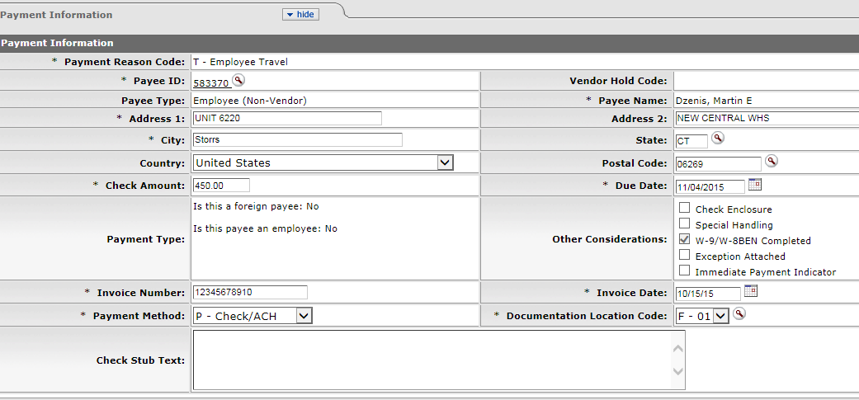
Invoice Number- 11 Digit Travel WebForm ID
Resubmitting after Disapproval ‘RS’ and previous Inv Num
Invoice Date- Last date of travel
-State or Country Code & First Travel Date

- On the Accounting Lines tab fill out the four required fields; Chart, Account Number, Object, and Amount. Use the lookup icons as needed. Total must match check amount and refund on Travel Reimbursement form.
- If there was a Travel Advance Issue for the trip you must add the accounting line (9044680) with the employee’s Sub Account (Employee’s Name) in the amount of the advance (always negative). The Object Code for this accounting line always 1170. Contact Travel Services if a Sub Account is not found. Enter the Travel WebForm Doc ID# in the Org Ref Id field for the advance accounting line (9044680).
- Add the approved Travel WebForm and all required documents on the Notes and Attachments tab. Click the Submit button on the bottom of the Disbursement Voucher.
Click “add”
Note Text-Required field. Open format for departmental use.

- When all required documentation is successfully attached click the “submit” button at the bottom of the form.

