Travel WebForm – Responses

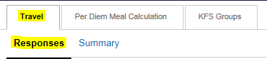
The Responses tab of the Travel Webform (TWF) is where you can review all pre and post trip forms that you have submitted, or that have been submitted for you by someone else. The first time you log in you will need to make sure you are on the Responses section of the Travel tab. If not make sure to click on this section before proceeding.

Before going into the details of the Response page here are some tips on how to set up the page the way you prefer.

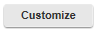
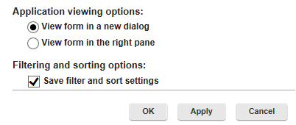
- You can customize your page so forms open in a new window instead of on the right hand side of the page. To do this fist click on the Customize button located right under the “Responses” link of the page. This will open a new box called “View Properties”. If you scroll down to the very end of the list make sure the option labeled “View form in a new dialog” is selected. Then click the apply button at the bottom, and finally you can exit the box by clicking ok.

- To sort how information appears, click on the title of the column you’re trying to sort. The column titles are listed in the dark blue row at the top of the screen. For Example, if you click on the “Last Updated On” header it will sort documents from oldest to newest. If you click again it will sort from the most recent updated to the oldest updated forms.

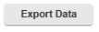
- You can also expand or minimize columns. For example: if you would like to expand the Stage column put your cursor between the Stage and Draft column. You should see the cursor change from the white pointer to an arrow pointing in opposite directions . When the cursor changes you can left click, hold, and drag the cursor over to the right or left to expand or minimize the columns.
- By clicking the Export Data button at the top of the screen you can export the data on the responses tab into an XML, Excel, or OpenDocument.
- The icon that’s located next to the Export Data button allows you to hide documents that have been completed and are in the End stage. You can always click on the icon a second time to unhide documents you have hidden.

When you are on the Responses page you will see the page is split up into two sections.
The left half of the screen shows the following information:
- Trip ID – ID given to each form submitted.
- Stage – tells you what the status is of your pre or post trip form.
  - Start: The form has been initiated but it was saved and never
  - Pre Trip – Promissory: A pre-trip form requesting an advance was submitted by a travel arranger. The form cannot move out of this stage until the traveler logs into the TWF and electronically signs the promissory note for their advance.
  - Pre Trip – Travel Services: The form has been routed to the Travel Office because either an advance, Bradley parking permit, or international health insurance was requested on the form. The pre-trip form cannot move out of this stage until the item(s) requested have been processed by the Travel Office.
  - Post Trip – Reimbursement: All items requested on the pre-trip form have been processed and the form is now completed. No further actions need to be taken until the post-trip form is filled out.
  - Post Trip – Traveler Certification – the post-trip form has been filled out for the traveler by another UConn affiliate. The traveler must now go into the form to electronically agree to the certification statement and “sign” their reimbursement form. The post-trip form cannot move out of this stage until this is completed.
  - Post Trip – Waiting for Approval: The traveler has electronically signed their reimbursement form. Now the form has been routed to the supervisor selected in the “Reimbursement Authorization” section of the post-trip form. If the supervisor approves the form it will route to the next stage.
  - End: Ocne the document has reached this stage it is finally ready to be submitted in KFS. The “KFS Processor” that was selected on the pre-trip form will receive an email notification when the form hits this stage.
- Draft – If the form is still a draft and not yet submitted there will be an icon in this field. You can click on the icon to launch the form and then you’ll have the option to either continue editing the form or you start over with a new form. Drafts will stay in this stage until they are either submitted or cancelled.
- Created By – Shows who initiated the document.
- Created On – Shows the date and time the TWF was initiated.
- Last Updated On – Shows the date and time the TWF was last updated
- The last information on this side of the form are three icons:
  - - Allows you to email a link to the form to someone.

  - - Allows you to print off a cover sheet of the form that includes information such as the initiator information and the TWF ID.

  - - Allows you to delete the record.

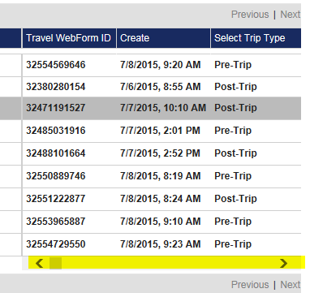
The right side of the page contains more columns detailing information that was selected in the form. You can use the scroll bar on the bottom of the right hand side of the page to view all of the columns.

Some columns will indicate whether the initiator has requested something specific on their form. For example: Under the column labeled “Parking (other than Bradley)” if you see the word “true” in this column it means the initiator has checked parking (other than Bradley) off on the pre-trip form as an anticipated expense.

- You can create filters for any criteria in the columns on the left or right hand side of the page by clicking on the Create Filters button located between the Customize and Refresh Data buttons at the top of the page. When you click this button a new search box will appear where you can select the item(s) you would like to filter on. For Example, if you would like to filter for documents that are for international travel you would follow these directions:

- Click the Select Item drop down.
- Hold the mouse over Travel which is the last selection on the drop down. This will cause a new list to appear on the right.
- Click on the option labeled Does your trip include foreign travel.
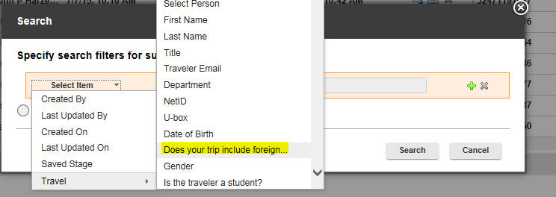

- Under the Choose Operator drop down list click on “Equals”.
- In the blank field type in “Yes”.
- You can then either click the search button or the green plus sign if you need to filter on another property.
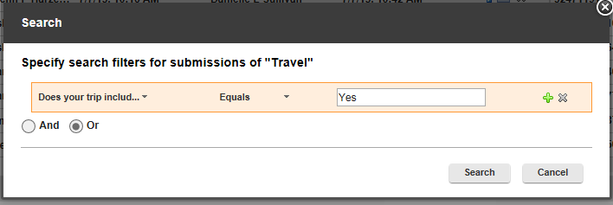

- Once you hit the search button the response you will see will be filtered for only trips that include foreign travel. To clear any set filters all you need to do is click on the “Clear Filters” link and all your results will once again be visible.

- Last, you can open any form by holding the cursor over the correct TWF until it is highlighted, and then left clicking. If you have customized your Responses tab to make the forms open in a new tab they will, and if you have not yet done this the form will open on the right side of the page.

