Filling out the Post-Trip Form – Pre-Trip form does exist

If a Pre-Trip Travel WebForm (TWF) was filled out for the traveler before they went on their trip then you have the ability to go into the Pre-Trip form to launch a Post-Trip form. Launching a Post-Trip form this way will save time by carrying information entered on the Pre-Trip form onto the Post-Trip form.

- You will first need to log into the TWF with your NetID and password once you click on the Responses link located on the top right of the Travel home page. Please note that only documents in the Post Trip – Reimbursement stage are ready to have the Post-Trip TWF filled out. Once you are logged in to the Responses page you will need to find the correct form in the Post Trip – Reimbursement stage and then click on the form which will launch the Post-Trip form. You will first see the Pre-Trip form that was filled out for the trip at the top of the page, so you will need to scroll down to the Reimbursement section to begin filling out the Post-Trip form.

- Reimbursement: This is the section where you will enter all the expenses that are being claimed. Please note that any expenses that were prepaid by UConn directly should not be entered on the Post-Trip form. Additionally, travelers who claim expenses that may be charged directly to the University must certify they have paid for the charges themselves, and that the expense has not been purchased through a UConn direct payment method.
  - Trip Dates: You will need to check off the first box if the actual trip dates were not the same as the dates entered on the Pre-Trip form. If you check off this box two additional fields will appear on the form where you can add the trip departure and return dates. If you do not check off this section you will not need to select departure and return dates.
  - University Affiliation: First select the affiliation of the traveler from the drop down list by clicking on the upside down triangle, and then clicking on the correct affiliation. This option will not be available if the reimbursement is for a guest. There will be other selections on the form that do not appear for guests since they are not applicable to non-University affiliates.
  - Duty Station: Use the drop down list again to select the traveler’s duty station.
  - Departure/Return Times: Click on the box or clock icon to choose the departure and return times. Hours are bolded, and quarter increments in between the hours are faded. Please be aware you can select any of these times listed. You will not be able to type in your own time so round the departure/return time to the nearest time provided on the list.
  - Transportation Stipend: This should only be checked off if the traveler receives compensation via payroll for transportation expenses. Please note only certain departments receive transportation stipends.
Once fields A-E have been filled out you may begin to fill out all the eligible business expenses from the trip on the tabs below. Any amounts entered on the tabs will calculate on the form below.

  - Airfare: On this tab you may enter airfare if the traveler paid for it themselves. If airfare is being claimed you must agree to the certification statement assuring the airfare was not paid directly by UConn through Sanditz. Baggage fees may also be entered in this section.
  - Registration: On this tab you may enter the amount the traveler paid for their registration. Again, you will need to check off the “I Agree” box first to certify this registration has not already been paid directly by a UConn ProCard.
  - Lodging: On this tab you may enter the amount the traveler paid for lodging after you have agreed to the certification statement provided. The lodging total may include parking, internet, or other in-policy expenses that were included on the hotel receipt. There is also a box provided on this tab where you can enter additional information.
  - Car Rental: On this tab you may enter the car rental amount. This is the last tab where you must first certify the expense has not been directly paid through UConn’s preferred vendor. If you did not book your rental car through Enterprise via Sanditz you must check off the box below the amount entered and then add a reason explaining why UConn’s contracted vendor was not used.
  - Meals: This tab consists of three separate ways to claim meals: Per Diem, Business Meals, and Meals with No Overnight Stay.
    - Per Diem: Please note receipts are not required for this section. Guidelines on how to claim per diem are written on the first paragraphs on this per diem tab.
      - To begin filling out the per diem section first check off if you are claiming a domestic or foreign per diem rate.
      - Next type in the location and use the correct per diem link to look up the meal and incidental rate for the area.
      - After you have typed in the travel location you need to deduct the meals that were provided during the trip. If the same meal(s) were provided on every single day of the trip select the provided meals from the drop down and the table below will populate with the eligible per diem. Ex: if breakfast was provided every day of the trip select breakfast only. If no meals were provided to the traveler or if different meals were provided each day first select “none” from the provided meals drop down list. Then click on the date a meal was provided, select the provided meal(s), and then click the update button.

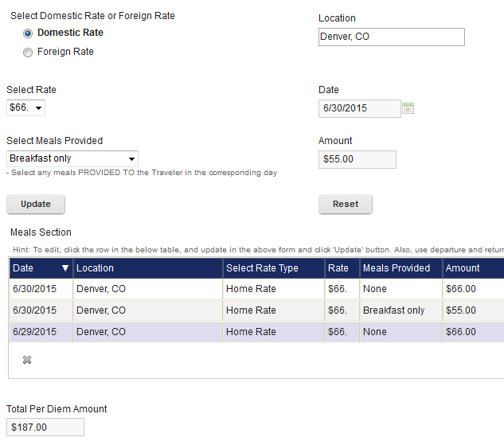

      - If the traveler would rather claim receipted meals instead of per diem they should not fill out the per diem rate section, but instead check off the “Receipted Meal Claim” box and enter the total receipted meal amount.

    - Business Meals: To claim a business meal you can either fill out the meal information on the table or you can click on the Business Meal Form link and then enter the total that form calculates to the TWF. To add an entry onto the TWF click on the green plus sign and then fill out the entry form. All boxes must be filled out in order to add the entry onto the table. To edit the entry click on the correct date and then on the pencil icon . To delete an entry on the table click on the dates and then on the .
    - Meals with no Overnight Stay: This section may be filled out if a traveler departed and returned on the same day. Policy points on how to claim meals for single day travel are listed below the “Select Meal” drop down box in this section. To claim meals you must fill out information in every box on this tab and then click the “Add” button at the bottom of the form. Once the meal entry is added it will appear on the Meals with No Overnight Stay table and this total will be added to the reimbursement. Please note you must add a separate entry for each meal claimed.
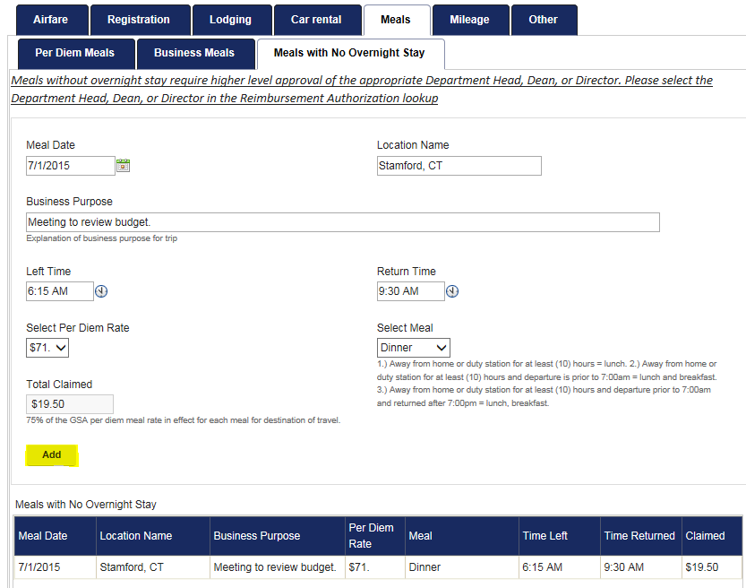

  - Mileage: All boxes on this tab must be filled out for mileage to calculate correctly.
    - In the “One way commute” box enter the one way mileage from the traveler’s home to their duty station.
    - Next enter the traveler’s home address. The town and State are the minimum requirement for this box.
    - Once these two boxes are filled out you may the first entry to the mileage log table. To begin, click on the green plus sign which will open up a new window where you can add the trip date, travel destinations, business purpose, total mileage driven, and if the traveler departed/returned to/from their duty station. Please note the Entered Mileage should always be one way mileage. Selecting “Yes” to roundtrip will double your entered mileage. Once you have filled out all required fields in this section click on the “Add” button. You can continue to add entries, or you may edit or delete entries by clicking on the date and the pencil or icons.
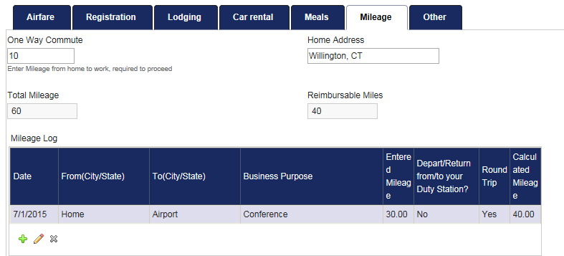

  - Other: In this section you may add any additional trip expenses to the table below that do not fall into the previous tabs. To add an entry click on the green plus sign and first fill out the date on which the expense was incurred.
    - If this expense falls into the transportation category use the drop down list in the Transportation section to find the expense description, and then enter the expense amount in the box provided. If “other” is selected a description providing more information must be entered.
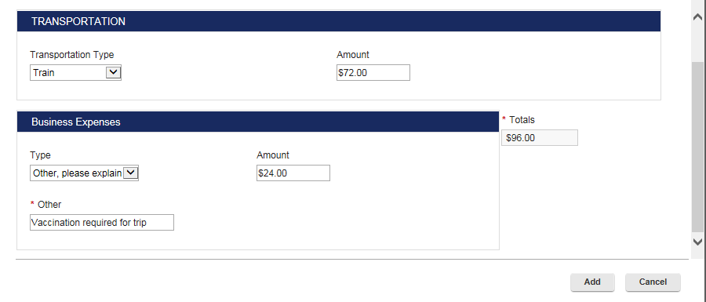
    - If the claim is for another type of business expense use the drop down box on the Business Expense section to find the claim description, and then enter the claim amount in the box provided. If “other” is selected a description providing more information must be entered.

You may add one Transportation and one Business Expense per entry onto the table. You can continue to add entries, or you may edit or delete entries by clicking on the date and the pencil or icons.

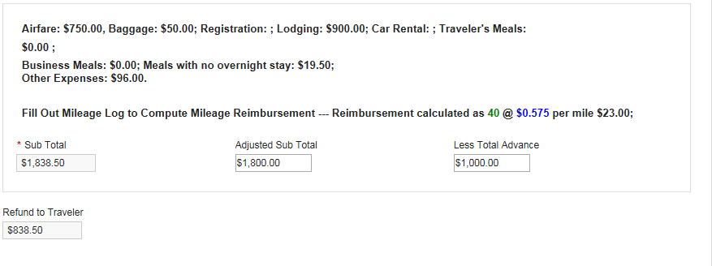
Once all trip expenses have been added on the reimbursement tabs your total claims will be calculated below in the “Sub Total” box. If the traveler would like to claim a partial reimbursement you may lower the claim amount in the “Adjusted Sub Total” box. If an advance was issued this amount should be entered in the “Less Total Advance” box. The amount in the “Refund to Traveler” box should be the amount entered in KFS.

The next two boxes include questions that only relate to Grant Funded Reimbursements. If the claims will not be Grant Funded these two boxes should be left blank. If the claims will be routed to Sponsored Program Services (SPS) for review you must answer these two questions below.
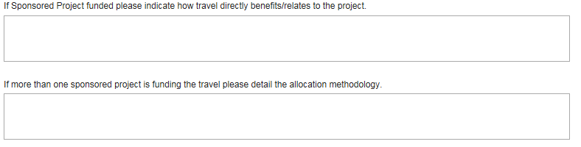

- KFS Accounts: In this section you may add the KFS account(s) you would like the entered expenses charged to. Please note that any prepaid expenses should not be added in this section. To add a KFS account enter the 7 digit account number, the amount that should be charged to it, and the object code in the corresponding boxes provided. Once this information is added you may click the “Add” button and the information will populate on a table below. To delete an entry added to the table click on the KFS account on the table and then on the icon.

- KFS Processor: This is a section where you can indicate which group will enter the traveler’s expenses into KFS.
  - Unit: Select the Division of the KFS Processor.
  - KFS Group: Select the Department of the KFS Processor. Please note that TWF Initiators can be a part of multiple different KFS Groups.
  - If you are filling out the post trip form for yourself you must click to agree to the Certification statement in this section before submitting the Post-Trip document. By clicking the “I Agree” box you are electronically signing the reimbursement form. If you are filling out the reimbursement for a UConn Affiliate this box will not show up for you. Once you submit the Post-Trip form an email notification will be sent to the traveler informing them that they must go into their Post-Trip document and electronically sign their own reimbursement form. The reimbursement form may not be submitted into KFS until the traveler completes this step.
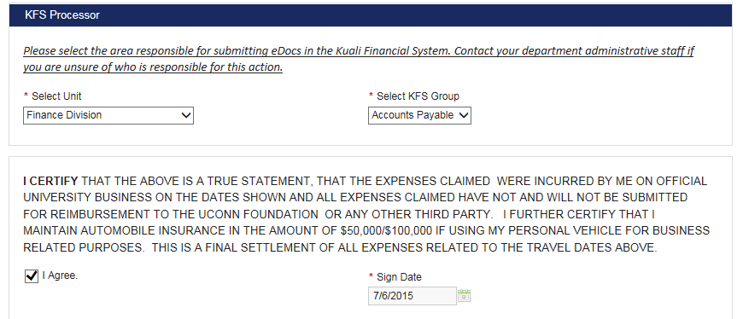

- Reimbursement Authorization: In this section you must select the traveler’s Supervisor so they may review and approve the claims before they’re submitted into KFS. The Supervisor selected must be on the next highest organizational level from the traveler. This search function works the exact same way as the search for Traveler Information.

- Post-Trip Notes: This is the last section of the Post-Trip form. You can add any notes you would like to record in this box, and then select the “Add Note to Table” button once you are ready to attach the note. TWF initiators can only add one note to the form before submission. Please be aware that added notes may not be deleted.

Additional Information

- Once you have completed all fields on the Post-Trip form you can select the Submit button. Or, if you are not ready to submit the form and you would like to save you progress you can check off the “I would like to save this as a draft” box and then click the “Save Draft” button.
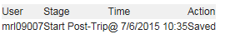
- There is a route log at the bottom of the form that shows you what actions have been taken and when. Ex: This form was saved on 07/01/15, and it has not been submitted yet.

- The Supervisor selected in the Reimbursement Authorization section may approve, return, or disapprove the Post-Trip TWF that was routed to them. Returned documents will be sent back to the TWF initiator with a note on what sections require revisions and adjustments before they may be resubmitted for approval. Disapproved documents may not be revised, and they must be resubmitted if the traveler would still like to claim expenses in KFS. The expenses may not be submitted in KFS until the Post-Trip TWF has been Approved by the Supervisor selected.
- The following email notifications will be sent out once the Post-Trip TWF is submitted:
  - Certification Statement – an email notification will be sent to the traveler to agree to the certification statement if they did not initiate their own TWF. The form will not route to the Reimbursement Authorizer for approval until the Post-Trip form is electronically signed by the traveler.
  - Reimbursement Authorizer – an email notification will be sent out to the Supervisor that was selected to review and approve the TWF.
  - KFS Processor – an email will be sent to the KFS Processor once the TWF is ready for submission in KFS. This notification will not be triggered until the Traveler has electronically signed their Post-Trip form and the Reimbursement Authorizer has approved the TWF.
  - Document Returned/Disapproval – an email notification will be sent to the TWF initiator if the Post-Trip form was returned or disapproved by the Reimbursement Authorizer that was selected on the form.

